Cloud-Native Diagnostic Microservice on GKE
In this project, build a small diagnostic tool that exposes system information, environment variables (like your GKE pod details), and a health check endpoint.
Architect diagram
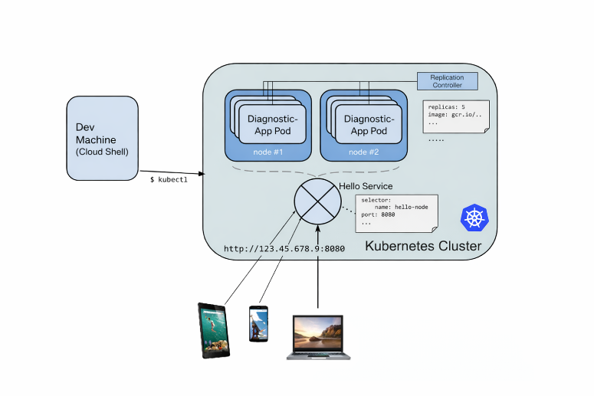
The Enhanced server.js
This script will provide:
- System Info: Displays the container's hostname (the Pod name) and memory usage.
- Environment Visibility: Prints key environment variables, which is vital for debugging ConfigMaps and Secrets.
- Liveness/Readiness Patterns: Includes a /healthz endpoint—the gold standard for GKE deployments.
const http = require('http');
const os = require('os');

const handleRequest = function(request, response) {
// 1. Health check endpoint (Essential for K8s probes)
if (request.url === '/healthz') {
response.writeHead(200);
response.end("OK");
return;
}

// 2. Operational Info payload
const info = {
message: "Node.js System Diagnostic Active",
podName: os.hostname(),
uptime: process.uptime(),
memoryUsage: process.memoryUsage().heapUsed / 1024 / 1024 + " MB",
appVersion: process.env.APP_VERSION || "1.0.0",
environment: process.env.NODE_ENV || "development"
};

response.writeHead(200, { 'Content-Type': 'application/json' });
response.end(JSON.stringify(info, null, 2));
};

const www = http.createServer(handleRequest);
www.listen(8080, () => {
console.log("Diagnostic server listening on port 8080");
});

--------------------------------------------------------------------------------------------------------------------------------------
Task 2. Create a Docker container image
To create a professional-grade container image, we must focus on security and image size. Instead of using the bulky default Node.js image, we will use node:22-alpine. This significantly reduces the attack surface and download time—a key practice for any DevOps engineer.
Dockerfile:
--------------------------------------------------------------------------------------------------------------------------------
# Use a lightweight Alpine-based image
FROM node:22-alpine

# Set a non-root user for security (Best Practice)
RUN addgroup -S appgroup && adduser -S appuser -G appgroup
USER appuser

# Set working directory
WORKDIR /app

# Copy package files first to leverage Docker layer caching
COPY package*.json ./

# Install dependencies
RUN npm install --production

# Copy the application source code
COPY server.js .

# Expose the application port
EXPOSE 8080

# Use CMD to start the application
CMD ["node", "server.js"]

The package.json
Since the Dockerfile uses npm install, ensure we have a package.json in the same directory so the container knows what to run:
{
"name": "gke-diagnostic-app",
"version": "1.0.0",
"description": "Diagnostic Node.js app for GKE labs",
"main": "server.js",
"scripts": {
"start": "node server.js"
}
}
First create a repository in Artifact Registry. Let's call it my-docker-repo. Run the following command:
-------------------------------------------------------------------
gcloud artifacts repositories create my-docker-repo \
--repository-format=docker \
--location=YOUR_REGION \
--project=YOUR_PROJECT_ID
----------------------------------------------------------------
To build GKE environment, run these commands in your terminal:
# Build the image
docker build -t gcr.io/PROJECT_ID/diagnostic-app:v1 .
Since we are using Google Artifact Registry, the process involves three key steps: authenticating our local Docker client, tagging image with the correct repository path, and finally, pushing the image.
Make sure our project ID is [PROJECT_ID], region is [REGION] (e.g., us-central1), and repository name is my-docker-repo, here is how to do it.
1. Authenticate Docker with Artifact Registry
Authorize the Docker CLI to talk to Google Cloud. Run this command in terminal:
Bash
gcloud auth configure-docker [REGION]-docker.pkg.dev
2. Tag Image
Before pushing, we must "tag" your local image to point it to your specific Google Artifact Registry path.
Bash
# Syntax: docker tag [LOCAL_IMAGE_NAME] [LOCATION]-docker.pkg.dev/[PROJECT_ID]/[REPOSITORY]/[IMAGE_NAME]:[TAG]

docker tag gke-diagnostic-app:latest [REGION]-docker.pkg.dev/[PROJECT_ID]/my-docker-repo/diagnostic-app:v1
- Tip: Always use version tags (like v1) instead of latest in production environments. It makes rollbacks much easier.
3. Push the Image
Now that the image is tagged with the registry URL, you can push it:
Bash
docker push [REGION]-docker.pkg.dev/[PROJECT_ID]/my-docker-repo/diagnostic-app:v1

# Push to your Google Container Registry or Artifact Registry
docker push gcr.io/[PROJECT_ID]/diagnostic-app:v1

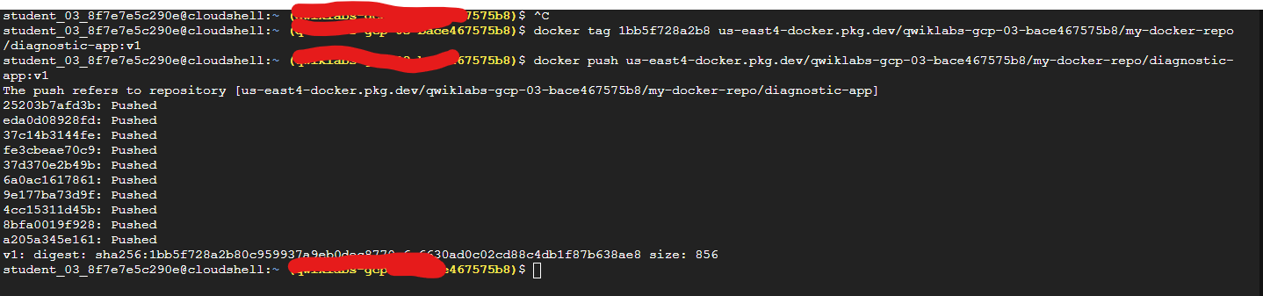

Task 3. Create your cluster
Now we are ready to create Kubernetes Engine cluster. A cluster consists of a Kubernetes master API server hosted by Google and a set of worker nodes. The worker nodes are Compute Engine virtual machines. Here we have created cluster whose name is hello-world with number of nodes:2 and machine type:ec2-medium at zone.
Creating Cluster on GKE
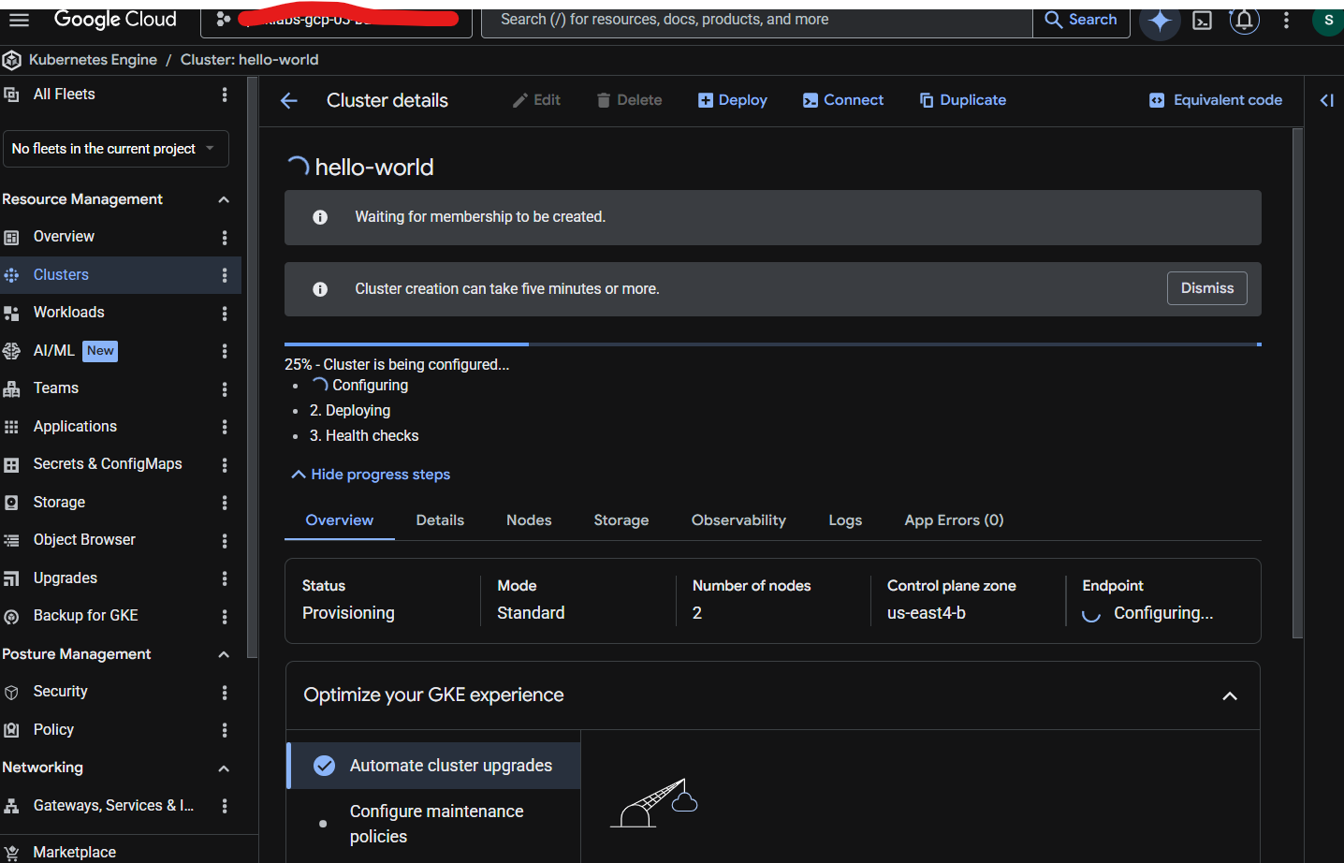
To deploy our application, we will use the kubectl create deployment command because we built image as diagnostic-app.
kubectl create deployment diagnostic-app \
--image=us-east4-docker.pkg.dev/PROJECT_ID/my-docker-repo/diagnostic-app:v1
To view the deployment and pods, run:
Kubectl get deployments
Kubectl get pods

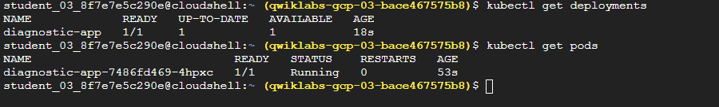
Currently we have 1 pod, lets scale it for 4 i.e replicas
kubectl scale deployment diagnostic-app --replicas=4

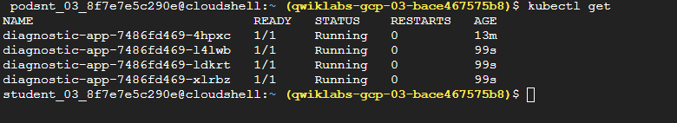
Since our pods is running internally, it's currently isolated from the outside world. To access it, we need to "expose" it by creating a Service. In GKE, the most common way to make an application accessible is through a LoadBalancer type service, which provisions an external IP address.
Expose Deployment
Run this command to create a load balancer that routes external traffic to pod on port 8080:
kubectl expose deployment diagnostic-app --type=LoadBalancer --port 80 --target-port 8080

The provisioning of a load balancer takes a minute or two. Run this command to check the status:
kubectl get service diagnostic-app
Keep running it until we see an EXTERNAL-IP appear. Once it does, copy that IP address and open it in your browser (e.g., http://[EXTERNAL_IP]) like below
http://34.21.67.151
